Graphic Design Activity

- Important elements
  - Core
    - Names of cheese/font
    - Start quiz button
    - End quiz button
    - Feedback for correctness
  - Supportive
    - Score tracking
    - Timer
    - Color (orange for prompt vs. yellow for answer field)
  - Extraneous
    - Advertisements
- My sketch of game
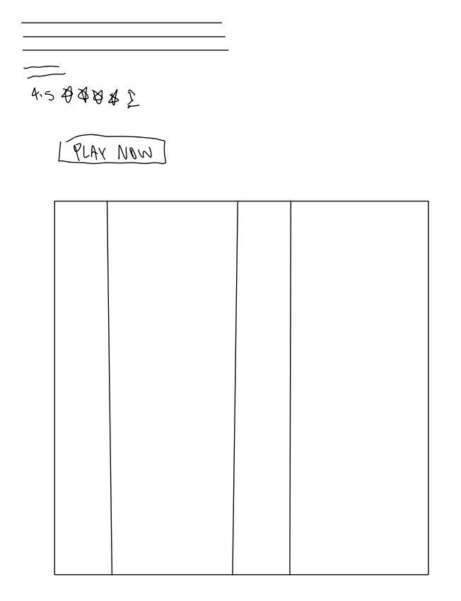

- One sketch emphasizing size
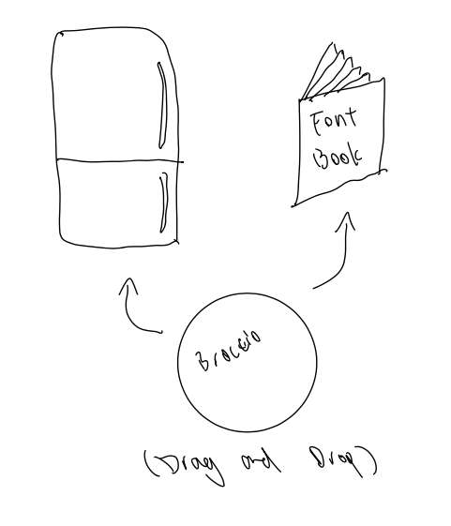
- One sketch emphasizing color
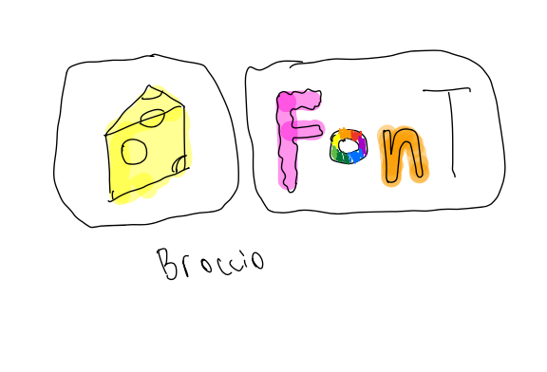

- 3-4 sketches involving fonts
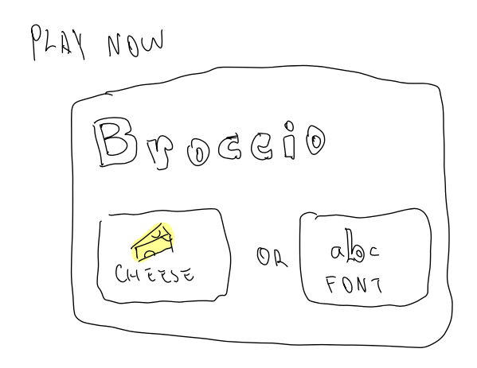
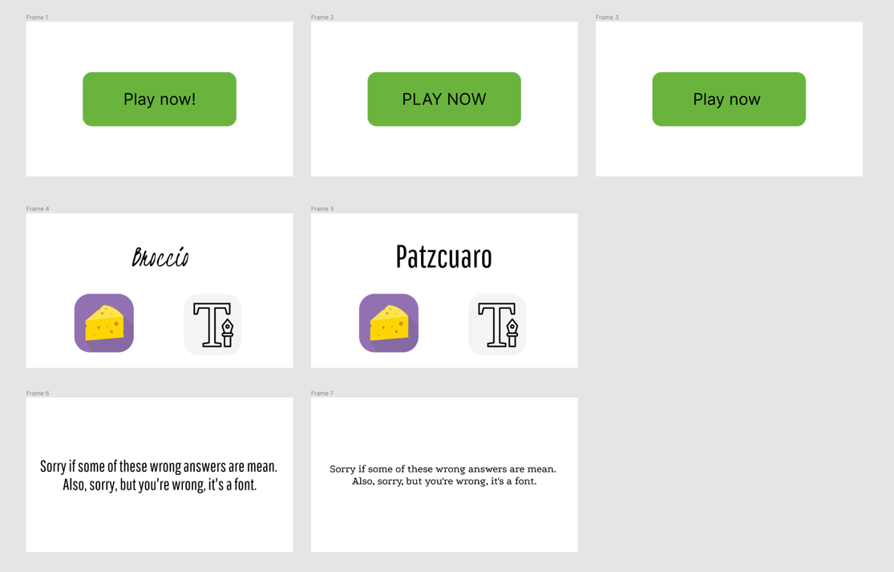

- Exploring proximity in design
  - My designs for cheese or font revolved around making each font/cheese its own level/screen, instead of the overly boring grid format we see in the current game. As a result, proximity isn’t as much of a concern as there are only ever 3 or fewer elements on the screen. If working with the original design, however, I would try to have a format where the cheese/fonts get grouped with their correct category after I answer, that way I can try to identify patterns moving forward.

- Analysis of Among Us
  - Color
    - The vibrant color palate in Among Us combined with its cartoonish style made for a very enduring visual appearance. It was flashy and attractive, yet was also functional as to not get boring after a while.
  - Size
    - Among us does a good job of sizing elements relative to their importance. For example, the setting and map buttons are smaller than the report/use/kill buttons. While settings and map could be important, they tend to be used more so when the game is at a slower pace, whereas report/use/kill are used to react to crucial events in the game
  - Font
    - Perhaps this is where Among Us is arguably weakest. While certain elements (“Total Tasks Completed”, “report”, “use”) have a handwritten font that is related to the aesthetics of the game, the primary text in the game (player names and room name) are in a formal type. While the legibility of this design choice can be seen as a strength, the juxtaposition against the stylized text gives the game an unfinished look.

